Issues Faces and Resolved



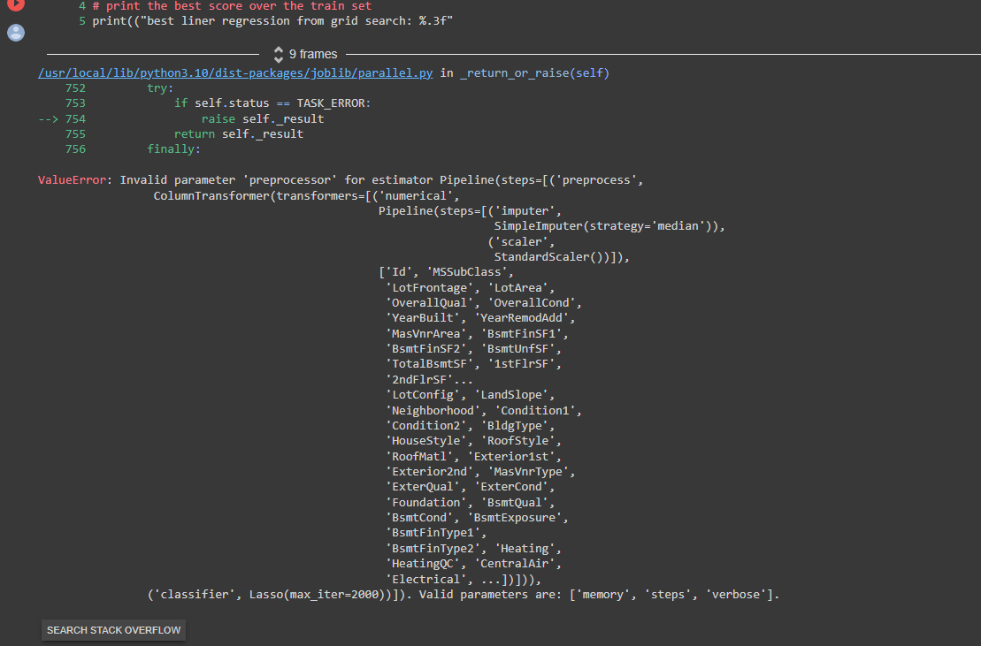

Solution :

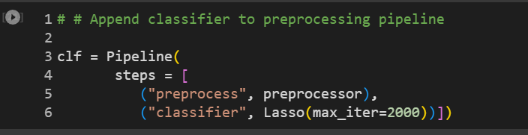

The above code had to be changed to below code

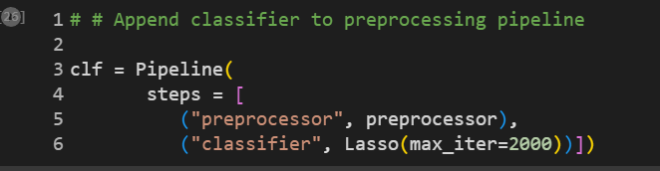

Instead of “preprocess” you have to change the code to “preprocessor”.